

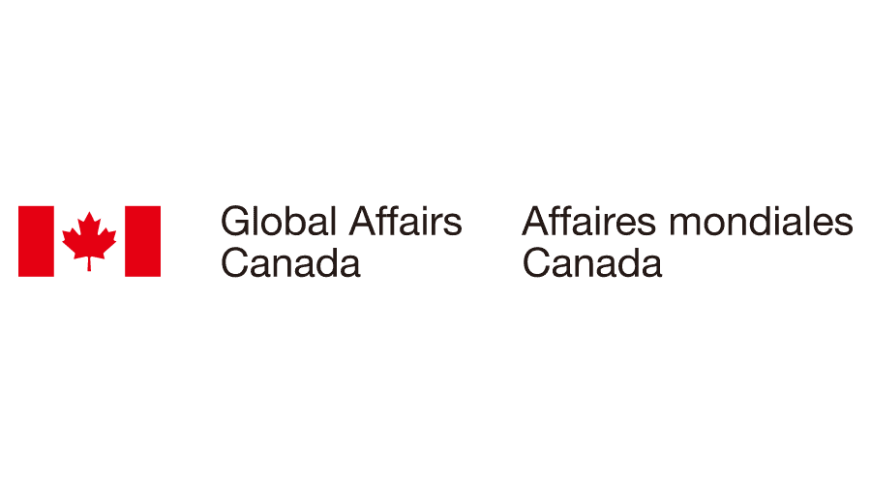

**CALL FOR PROJECTS 2025: Stigma in Justice Project**

**Application Form**

***Application deadline: 25 February, 2025***

|  |  |
| --- | --- |
| **Name of the organisation** |  |
| **Country of project implementation** |  |
| **Registration number and country of registration** |  |
| **E-mail address contact person** |  |
| **E-mail address organisation** |  |
| **Links to your website and social media** |  |

* **Please remain within the word limit of each question.**
* **Please use Times New Roman, 12 point font when filling out the form.**

1. **Description of Your Organisation**

**A.1** Introduce your organisation and its track record in addressing justice and CRSV-related issues. (Maximum 300 words)

**A.2** What are the core values of your organisation? (Maximum 100 words)

**A.3** Describe key partnerships with other organisations, CSOs, or survivor networks. (Maximum 200 words)

# **B. Proposed Project Description**

|  |  |
| --- | --- |
| **Project title** *(propose a title for your project)* |  |
| **Project location** *(where (which city/region/country) will the project be implemented)* |  |

**B.1 Context**

What are the challenges CRSV survivors face within the justice system in your country, particularly regarding stigma, myths, and misconceptions that your project would like to address? (Maximum 300 words)

**B.2 Project Goal**

Explain how your project will contribute to increase recognition among justice institutions and actors of how stigma, myths, and misconceptions about Conflict-Related Sexual Violence affect the progress of CRSV cases. (Maximum 300 words)

**B.3 Toolkit Justice Functions Focus**

Which of the following justice functions of the toolkit are you interested in testing and using?  
You may select more than one option:

Several selections are allowed:

* Legislative framework
* Access to Justice and survivor pathways
* Support services
* Investigation
* Witness Protection
* Medical and Forensic
* Prosecution
* Defense
* Judicial Function and Court Services

**B.4 Describe your Proposed Project and Key Activities**

You can refer to the Call for Projects 2025 document for indicative project activities, but we encourage you to identify other project activities that you consider relevant. In your description, please be sure to include information on who the target beneficiary group of your activities will be and how many people you intend to target.(Maximum 1500 words).

**B5. Project Approach and Methodology**

* Describe how you will gather data on stigma in justice processes, including data collection methods (surveys, interviews, focus groups,) and how this will inform your project's advocacy reports (if you choose to conduct advocacy as part of your project). (Maximum 300 words)
* Highlight how you will work with survivors, survivor networks and judicial actors providing a survivor-centred and trauma-informed approach. (Maximum 300 words)
* Please describe how you will ensure confidentiality and security of survivors. (Maximum 300 words).

**B6. Results and Sustainability**

What results do you expect from the project, and how will the results have a lasting/sustainable impact on the ability of your organisation to better support survivors of CRSV? (Maximum 300 words).

**C. Proposed Project Duration & Timeline**

* What is the duration of your project? Please specify the project’s start and end dates, ensuring they fall within the required duration of 6 to 18 months. (Maximum 100 words).
* Timeline: Provide an overview of major milestones (e.g., data collection, toolkit training ,advocacy report drafting etc). (Maximum 300 words).

**D. Budget**

How much are you applying for? Please provide a rough estimate of the funding requested (within the EUR 75,000 – 180,000 range), noting that you will be asked to submit a detailed budget later. Please include the following categories in your estimate:

* Salaries and Fringe Benefits
* Professional Services
* Travel Costs
* Supplies
* Other Direct Costs
* Overhead (%) *(maximum 12%)*

**E. Any Other Information**

You can provide any other information that you think is relevant to know about your organisation or the project here :